Meeting Minutes
Mar. 11, 2019
1:30 p.m. – 2:30 p.m.
ELS 217
Attendees: Ryan Kelly, John Hall, Kimberley Davis, Daniel Parker, Rob Williams
Meeting called to order at 1:35 by Kim (facilitating for Annette).
(No quorum, but no voting planned; meeting as informational and review of Friday)

Kim mentioned upcoming CAEP Conference (Denver).
Based on Friday conversations, Dispositions assessment (LiveText) to be used by Ed Leadership, Reading, GT, Special Ed.
Kim also mentioned partnership agreements. Potentially digging a bit deeper and having a sub-committee for partnership agreements (to make sure there are similarities in terms of CAEP-based language). Also, the possibility if the partnership agreement needs to be redone due to changing placements in some program, or if they change their mentor.
Partnership: 1) Upon admission, 2) Prior to Internship/Practicum, 3) End of Program
Dispositions: 1) Upon admission (self-evaluation), 2) Prior to Internship/Practicum (self-evaluation), 3) End of Program (self-evaluation and mentor).
Kim mentioned external program review work and what she has seen about internal review, and the possibility of being able to provide internal-level review (content) that an external review won’t be able to provide.
Such review would be with an internal Rubric aligned to CAEP’s SPA review rubric.
Request from Kim to be thinking about questions that we have examining technology’s role in our programs.
And Is ProEthica necessary (ethics)?
John mentioned the need for the core demographic questions/data points that the employer survey will need.
Meeting adjourned at 2:30 PM.
Minutes approved 4-8-19 (see 4-8-19 APAC Agenda)

From the Marker Board:
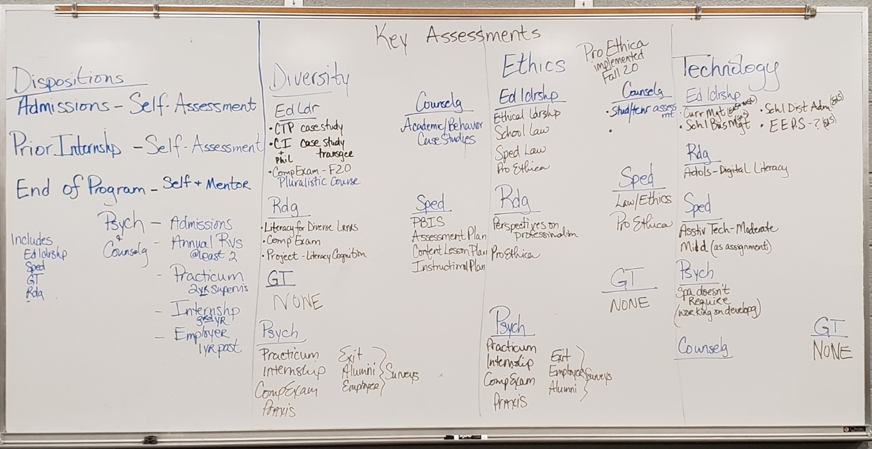

Meeting Reminders:
March 25: Meet with Advanced Standards Committee
April 5: 2nd Assessment Retreat
April 22: Meet with Advanced Standards Committee
May 13: Review APAC Goals and Assessment Plan for 2019-2020

